**Examples of poor storytelling**

**Introduction**

Along the journey of Microsoft Power BI dashboards, the art of data storytelling often meets pitfalls. These can include a chaotic dashboard canvas, vague visuals included on the canvas, and a disconnected narrative throughout the data presented.

In this reading, you will explore real-life examples of poor storytelling with Microsoft Power BI and diagnose the issues that hinder effective communication of data insights.

**Example 1: Chaotic canvas**

A cluttered Power BI dashboard is the most common example of ineffective storytelling. When the Power Bi canvas is overloaded with graphs, charts, and widgets, it becomes challenging to interpret the key message. The end users of the story are bombarded with too much information, leading to confusion rather than clarity.

This issue typically arises due to a lack of visual hierarchy and focus. Effective storytelling requires a thoughtful layout design. The dashboard should be a clear reflection of the story you are telling. An effective dashboard will guide the viewers’ eyes along the flow of the story with coherence and simplicity.

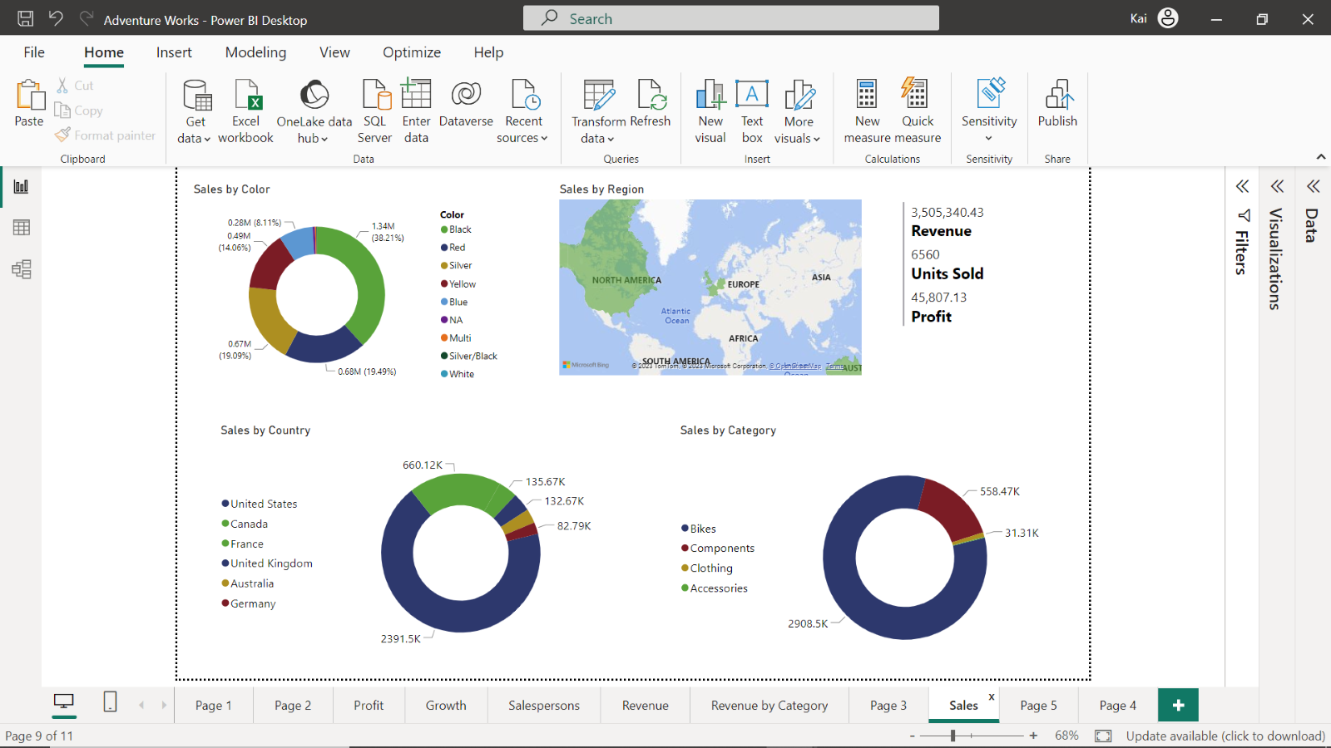

In this sales dashboard, there is no logical sequence to the visuals presented. The overall canvas is disorganized, and there is no clear indicator of what information to focus on or why. The goal and purpose are not evident.

**Example 2: Vague visuals**

Another common example is a dashboard with visually appealing charts, but they lack clarity, or the chart type utilized does not fit the type of data being presented.

A good indicator that a chart is ineffective in portraying the selected data includes pie charts with too many segments, bar charts with incorrect orientation, and scatter or plot charts without a specified legend. The ineffective use of charts leaves viewers puzzled.

The appropriate use of charts according to data type is a significant element in crafting an engaging data story. A chart visual should communicate its purpose and significance effortlessly.

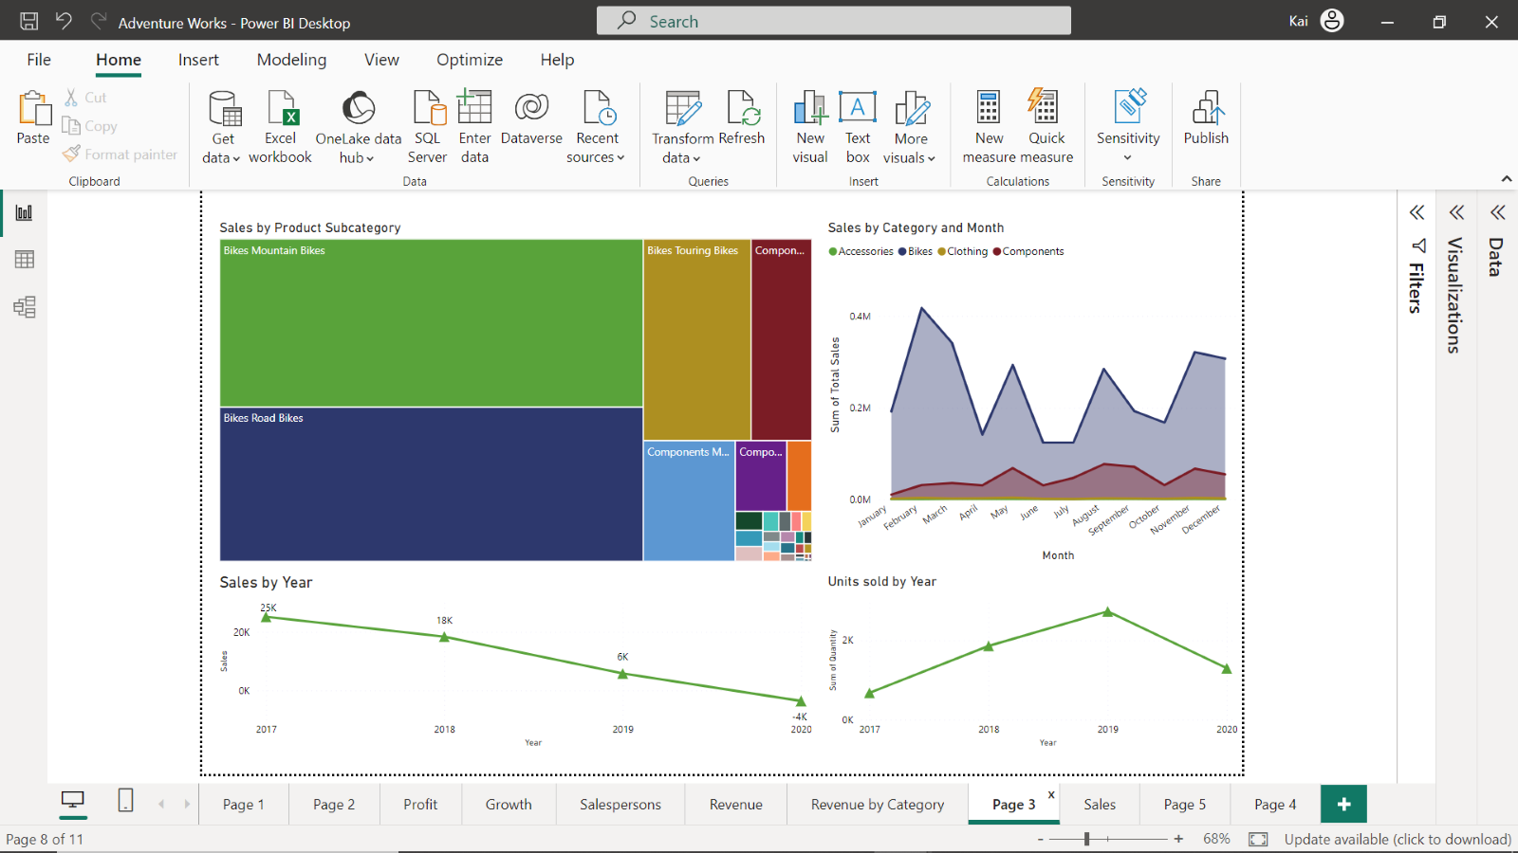

This dashboard presents how a wrong chart type will ruin your data story. The Sales by Product Subcategory treemap chart features too many colors without any data labels. The sales by year and units sold by year would be better presented as a bar or column chart with data labels, as there are only a few data points. With effective visuals, specifically charts effectively presenting data, users can clearly follow the story you are telling.

**Example 3: Disconnected narrative**

Another instance of poor storytelling dashboard is when the narrative is disconnected. An example of this is when the visual elements of the dashboard seem like a standalone story, lacking a connection that ties them together. Viewers are left struggling to grasp the story you are trying to tell.

The problem lies in having no clear goal, leading to an absence of narrative thread in the dashboard. A compelling data story means connecting the dots between visuals to form a coherent narrative. A story plot supported by a clear goal should guide your audience through the data, from problem identification to solution.

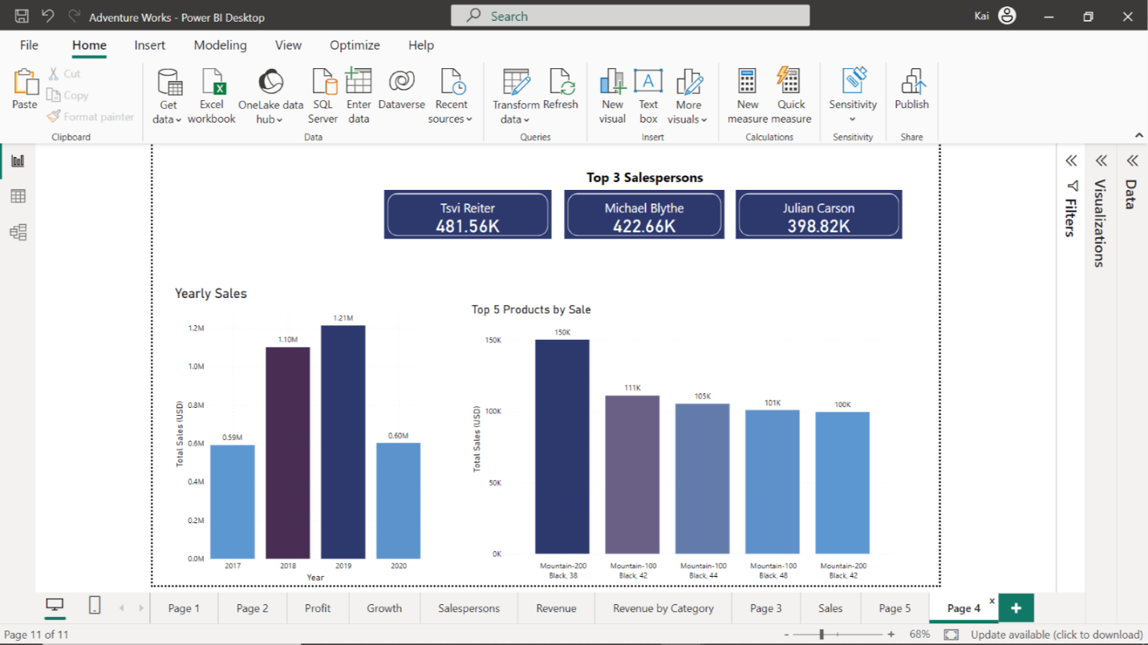

The dashboard looks visually appealing, but there is no clear story to what is being presented. Careful investigation of the report reveals that each visual element represents an independent data story. Card visuals represent the top three salespersons that should be part of the Salesperson dashboard. Yearly sales and top 5 products are related to sales and products dashboards, respectively.

**Data visualization mistakes to avoid**

1. **Including too many variables**

The whole point of data visualization is to tell a story. Therefore, you need to include relevant information while excluding unnecessary details.

You should first identify the necessary variables you want to visualize which then direct you to choose a visual format. A pie chart, for example, that compares too many variables will make it difficult to comprehend the data and see the difference between values.

1. **Poor color choices**

The proper use of colors allows viewers to understand the data you are trying to communicate. However, there can be challenges that arise when incorporating colors into your visuals.

Some typical issues that arise when using colors in your visualization include:

* Using too many colors, making it difficult for the viewer to quickly understand that they are looking at.
* Using colors with little contrast between one another.
* Not accounting for viewers who may have visual disabilities.

A typical example of color issues is with map visuals. Imagine a map visual of the United States of America, showing the sales amount for Adventure Works in every state. Colors are used to represent the different sales values per State.

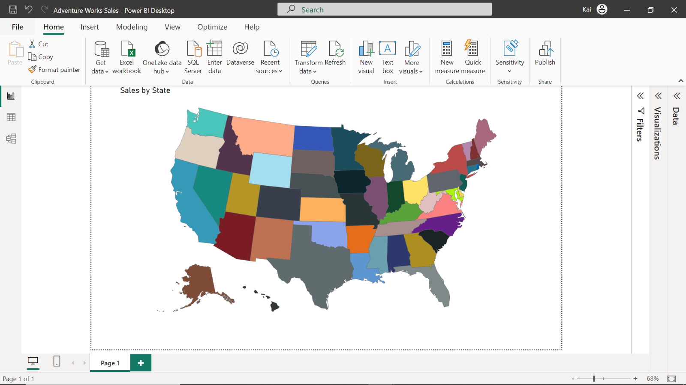

Instead of using three complimentary colors to indicate a high volume of sales, a moderate volume of sales, and a low volume of sales, a gradient has been used. The three shades are not distinguishable enough, and as the viewer observes the map there is no clarity.

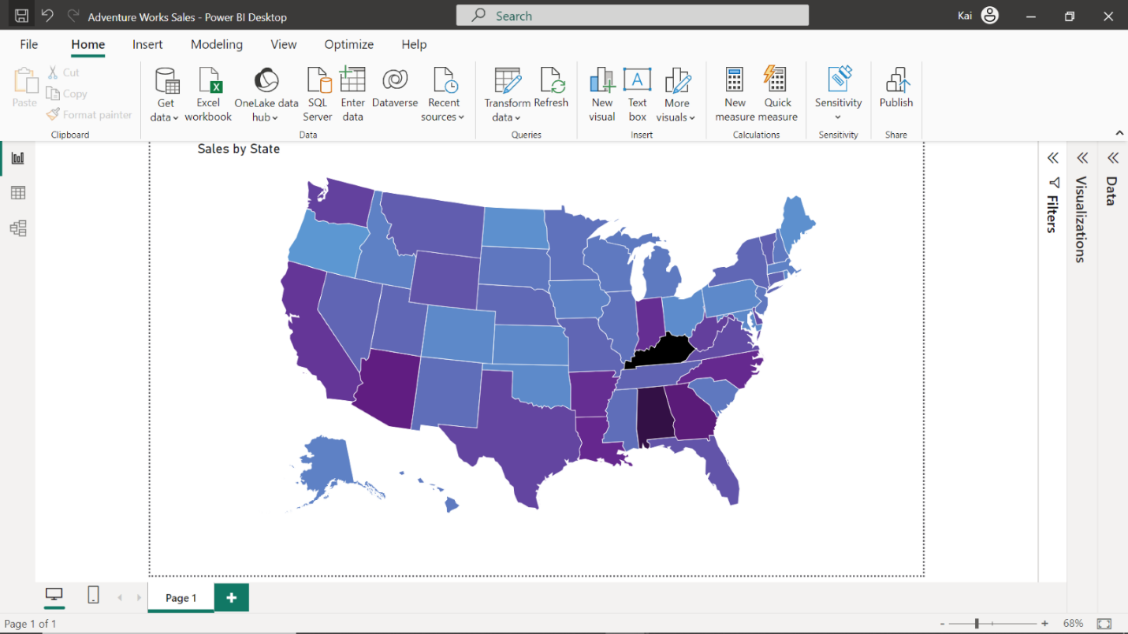

1. **Too many slicers**

The use of too many slicers in your dashboard obscures the story behind your data. You need to make sure to design your report interactions in a proper way, and slicers are not always the best option, especially when they have a lot of elements.

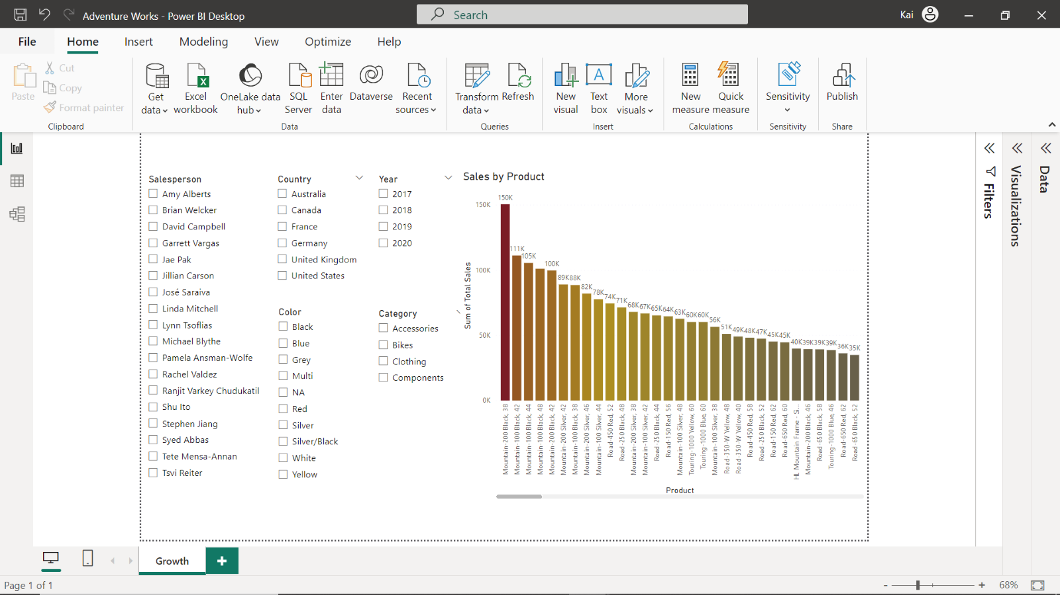

In the above dashboard, too many slicers make it difficult to comprehend the message of the story.

1. **Confusing page layout**

Too many visual elements on your canvas means you will be unable to communicate clearly with the viewer.

Importing all the graphs and charts from your reports to a dashboard is an ineffective way to build your narrative. It brings clutter to your story and there is no way to know for certain what to pay attention to.

The standard rule to follow when designing dashboards is that people read from left to right and from top to bottom. This means you should always put your most important visualizations and most critical KPIs (Key Performance Indicators) to the left and top of the dashboard. You can then add details to the right and bottom of the report canvas to reinforce this message.

**Conclusion**

In the real-world of data analysis, you will encounter more examples of poor storytelling including inappropriate use of visuals, data overload, and disconnected narratives.

Remember, in Microsoft Power BI, as in any other form of storytelling, less can often be more. Simplicity, clarity, and context are your allies in communicating data insights effectively.

Go to next item